Hello from Sand Mountain Park & Amphitheater!

We are so excited to announce our virtual or in-person Miles for Miracles March challenge! The challenge is to run/walk/bike 100, 50, or 25 miles from March 1st – March 31st. Please share the link below and encourage people and businesses to donate PER MILE, and you or your business are welcome to participate in the challenge as well! Our Mission is to dramatically improve the health and economic vitality of the Sand Mountain region, and we are asking for your support to help make a positive difference in our community!

100% of all donations go to the Albertville Parks & Recreation Foundation and will directly support our Miracle League (special needs baseball league) and our Youth Recreation Sports Scholarship program. Please click on the link below to donate and help us reach our Team goal of $10,000. Please share this link with anyone that would be interested in supporting this initiative. It is going to be an annual fundraising challenge at the park that also facilitates improving mental and physical health!

We have 141 Miracle League players this Spring season, and we serve over 2,500 youth recreation athletes throughout the year. Providing everyone the opportunity to play is one of the most important aspects of our Mission, and these funds will help expand recreational sport opportunities for kids & special needs citizens within our community. The funds will also be used to pay for youth recreation league registration fees (under privileged kids), recreation facility improvements, and the addition of a special needs playground. Please consider supporting this awesome cause on our behalf and help raise dollars that will make a huge impact. Let's WIN THE DAY together!!

https://runsignup.com/Race/AL/Albertville/SMPAVirtualMilesforMiracles

We greatly appreciate your consideration and look forward to joining and/or supporting us in this extremely important fundraiser.
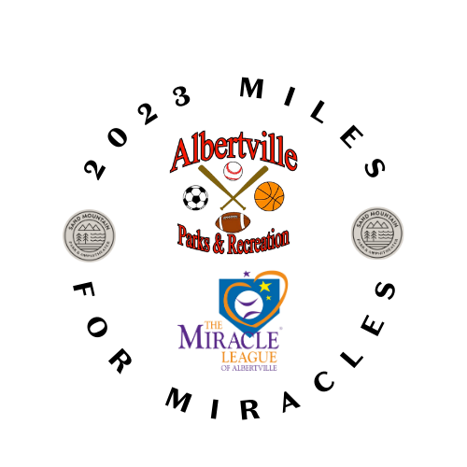

Sincerely,

The Sand Mountain Park & Amphitheater Team

